Visual Analytics for Reliable Software Fuzz Testing

ZHAO XIAOTIAN
CCTF in NTU
21/5/2025
Wang Yong

- Abstract
At present, the fuzz testing process is a black box, and test engineers cannot directly obtain the internal information of fuzz testing from the outside. Therefore, the test engineers are in a process of continuous trial and error without a goal in the whole fuzz testing process. The purpose of this paper is to develop a visualization tool for fuzz testing. When test engineers perform fuzz testing, they can use this visualization tool to analyze the fuzz testing process, which is convenient for test engineers to perform the next test based on the current coverage, code bottleneck and other information, thus improving the efficiency of fuzz testing.
We used afl++ as a fuzz testing tool and gcov to test the code coverage. The current progress is the visual analysis stage. We found that fuzz testing has many mutation strategies. After each mutation, it will analyze whether there is new coverage to guide the code to execute in different branches. We write log code in the afl++ code to output log information, and obtain the information before, during and after mutation of all seeds. We will analyze this information later. In addition, this research project was accepted in the FSE workshop 2025 in March this year, with the title Human in the Loop for Fuzz Testing: Literature Review and the Road Ahead.

- Contents
Introduction ---------------------------------------------------------------------------------------------- 1
Literature Review --------------------------------------------------------------------------------------- 1
Methodology --------------------------------------------------------------------------------------------- 4
Result ------------------------------------------------------------------------------------------------------ 6
Discussion ------------------------------------------------------------------------------------------------ 8
References ------------------------------------------------------------------------------------------------ 9

- Introduction
Fuzz testing is a dynamic software testing technique that subjects a program to random inputs to identify anomalies like crashes and other security threats. This method aims to uncover software bugs that could be exploited by malicious entities, thus enhancing the security and reliability of the software. Since its concept is introduced in the 1990s, fuzz testing has gained significant traction in both industrial and academic, evolving considerably in terms of effectiveness and efficiency.
Modern fuzzing workflows can be deconstructed into five iterative phases, including:
Instrumentation: Embedding feedback mechanisms (e.g., coverage tracking) into target programs.
Initial Seed Selection: Curating initial test inputs that bootstrap meaningful exploration.
Search Strategy & Power Scheduling: Prioritizing seeds with high potential to trigger novel software behavior.
Mutation: Applying transformations of the fuzz corpora to generate new test cases.
Execution & Monitoring: Detecting crashes, hangs, or security-relevant anomalies.
The current problem is that test engineers are unable to make reasonable judgments on the current fuzz testing process, which results in low efficiency for engineers when performing fuzz testing.
We hope to design a visualization tool that can be deployed on the front-end page of afl++ to provide guidance to test engineers during the fuzz testing process.

- Literature Review
Current fuzz testing faces challenges in determining its effectiveness, especially for domain-specific software. To address this issue, human intervention and automation in fuzz testing need to complement each other, leveraging their respective strengths. This semi-automated approach is a significant way to improve testing effectiveness. We analyze the existing literature on fuzz testing based on its five fundamental steps: instrumentation, initial seed selection, search strategy, power scheduling, mutation, and execution.

To facilitate expert intervention, researchers have explored various visualization methods to enhance the understanding of fuzz testing processes and provide actionable recommendations for human-guided adjustments.
The first stage is instrumentation, which involves instrumenting the target to obtain feedback. Here, FUZZPLANNER visualizes the entire firmware emulation process by presenting data and workflow interactions through a timeline, binaries table, and binary graph. FuzzInspector also employs a visualization-based approach, displaying data directly on the user interface. This helps developers understand differences between execution paths and identify functions with low code coverage.
The second stage is initial seed selection, where initial seeds are chosen to start the fuzzing campaign. In this stage, the program typically collects interesting seeds for subsequent steps. FUZZPLANNER interacts with the user during this process to gather seeds. The selection of initial seeds is crucial, as it helps streamline the subsequent steps in the fuzzing process. Grishin M et al. (2022) conducted a study. The core objective of this study is to enable security experts to manually control the fuzzing process and selectively choose the next seed for testing. HaCRS uses human assistance to break through the “semantic barriers” and it gives its human assistants a goal: generate an input test case. Qian Yan et al. (2023) proposed Infuzz, an interactive tool that assists testers in understanding and optimizing fuzzing efficiency. In the initial seed selection phase, the tool visualizes seed execution results, demonstrating how different seeds impact code coverage. By identifying seeds that are more likely to trigger new execution paths, the tool provides recommendations to testers, enabling them to manually refine seed selection for improved coverage. Similarly, Fioraldi and Daniele (2021) introduced a tool that employs invariant analysis to highlight code paths that are difficult to reach under fuzzer-generated inputs. In this approach, human intervention plays a crucial role in refining the fuzzing process. Experts can analyze the identified invariants to determine their relevance and adjust fuzzing targets accordingly, leading to improved initial seed selection. The DEFT proposed by YIFENG PENG et al. (2023) incorporates human-computer interaction by utilizing log file analysis to extract key state transition information from existing 5G protocol test data. This provides researchers with a selectable range of suitable seeds, after which humans can further optimize the input by adjusting the length of log segments.
The third stage is search strategy and power scheduling, which involves selecting a seed that triggers interesting behavior to guide the fuzzing process effectively. Infuzz helps testers recognize code coverage bottlenecks by explicitly displaying executed and unexplored code paths, thereby supporting more targeted fuzzing efforts. DEFT employs machine learning and deep learning techniques to assist. Specifically, the trained model is capable of automatically classifying vulnerabilities in log files and predicting the protocol layers affected by fuzzing. Human intervention is involved in the selection of model parameters and influences the training process.
The fourth stage is mutation, which applies modifications to the selected seed until its allocated energy is exhausted. This stage is a critical step in fuzz testing, focusing on the mutation of seeds. Developers create mutated seeds through various methods, making it an important point for human involvement. For example, FuzzInspector transforms mutated seeds based on constraint formulas to generate seeds that comply with the constraints. Meanwhile, FMViz visualizes the mutation process as images, allowing users to observe changes in individual pixels to determine mutations. Furthermore, in Fioraldi and Daniele’s research (2021), visualization techniques are used to distinguish between effective and ineffective mutations, offering insights into an intelligent mutation strategy. Human testers can leverage this information to refine mutation techniques, ensuring that they align more closely with the logical constraints of the target program.
The fifth stage is execution, which involves running the mutated inputs and monitoring them for interesting behaviors, such as crashes or new code coverage. This step is also a key stage requiring human involvement, as it demands extensive manual observation. FuzzSplore is a typical example of this, where human observation of scatter plots, coverage graphs, generation graphs, and filtering panels helps in selecting different subsets of fuzzing inputs to choose a more appropriate fuzzer. Additionally, by examining scatter plots and coverage graphs, it allows the identification of interesting test cases, thereby improving coverage. VisFuzz enhances fuzz testing efficiency through the observation of monitoring charts. If a significant amount of time has passed since the last new path was discovered, it indicates a bottleneck. By analyzing call graphs and control flow graphs, it can also identify rarely executed basic blocks. This visualization approach significantly boosts the efficiency of the fuzzing process. Additionally, this stage allows users to extract a wealth of information from the visualization interface, including seed information, setting breakpoints, and accessing registers and CPU details, as highlighted by FuzzInspector. It also enables the connection of multiple fuzzers, helping to identify which fuzzer exhibits stronger path exploration capabilities. Ijon allows users to manually annotate the code under test. This human intervention provides the fuzzer with more detailed information representing the internal state of the program, enabling a more systematic exploration of program behavior, which in turn assists the fuzzer in overcoming challenges that were previously insurmountable. The Use of Data Visualization in Fuzz Test Monitoring demonstrates real-time visualization of CPU and memory usage, enabling interaction through zooming, dragging, and mouse actions. Fuzz Introspector similarly visualizes reachability data, cumulative complexity, and control flow code coverage through charts, providing test developers with valuable high-level insights. In a study by Joshua Bundt et al. (2022), a test developer can use the weighted list of compartments to prioritize human efforts in improving fuzzing effectiveness and efficiency. Additionally, in FuzzFactory, users can design their own is waypoint predicate, which allows them to create a custom feedback mechanism. They can specify which specific optimization goals to focus on, provide seed inputs and mutation rules, and then automatically analyze patterns of system information leakage.
There are basically five parts mentioned above in fuzz. In our study, we found that a lot of work provides a lot of human guidance for the execution and mutation parts to improve the performance and efficiency of fuzz, among which the improvement in the execution part is the largest. These studies underscore the significance of expert-assisted fuzz testing, where visualization techniques not only enhance understanding but also enable targeted interventions to optimize testing effectiveness.

- Methodology
Following the fuzzing process steps outlined in Sriteja Kummita's research, we abstract the fuzzing process into five key stages and use this framework to search for research papers on human involvement in fuzzing. Human involvement in fuzzing refers to instances where human intervention assists the fuzzing process at any of the five defined stages, such as modifying mutated seeds or analyzing visualized data to identify bottlenecks.
We searched for fuzzing-related papers across various conferences and journals, including ASE, Fuzzing Workshop, IEEE Access, Big Data, SIGSAC, DSC, VizSec, NDSS, TOSEM, FGCS, JSS, COMPUT SECUR, WOOT, ICST, RAID, SP, CCS, USENIX Security, ISSTA, and ESEC/FSE, and identified 61 relevant papers. Through manual review, we determined that 19 of these papers explicitly involve human participation in the fuzzing process.
After the papers are collected, we will include the following rules in the criteria for whether the papers are selected:
The paper must be in English.
The selected papers must be directly related to fuzzing and explicitly include aspects of human involvement in the fuzzing process.
The paper has less than 4 pages.
Books, keynote records, panel summaries, technical reports, theses, tool demos papers, editorials, or venues not subject to a full peer-review process.
Just mentioning fuzzing without human involvement.
We conducted three rounds of searching and filtering to identify relevant papers. In the first round, we selected several seminal papers on human involvement in fuzzing, which provided a solid foundation for our subsequent selection process. In the second round, we expanded our search by examining the citations of these seminal papers and performing extensive keyword-based searches, ultimately identifying a total of 61 papers. In the third round, we carefully filtered these papers to retain only those that explicitly involved human participation in the fuzzing process. Specifically, we excluded any papers that focused solely on fully automated fuzzing tools.
We found that the earliest study among the selected papers was a 2014 master's thesis. Research on this topic gradually increased over the years, reaching its peak in 2023, which accounted for 38.9\% of the total papers. We also analyzed the publication venues of these papers and found that the Fuzzing Workshop and papers published solely on arXiv were the most common, each making up 11.1\% of the total. Other notable publication venues included VisSec, ASE, JISE, USENIX Security, Software, Big Data, ADFSL, SP, SIGSAC, Access, OpenSSF, ICST, and PACMPL.
After completing the literature research, we started to practice. The first thing we did was to use afl++. Since we had no experience using afl++, it took us about three weeks to successfully execute afl++. After executing afl++, we analyzed the core code of afl++, mainly the afl_fuzz_original, save_if_interetsing and common_fuzz_stuff functions in the afl_fuzz_one, afl_fuzz_run and afl_fuzz_bitmap files. These three functions constitute the core logic of afl++ execution, reading the unmutated seed, executing the mutation logic and saving if there is a higher coverage or crash.
I first read the functions of these three files, found the relevant execution code, and tried to understand its execution logic. Since there are many execution forks in the core code of afl++, it took me a long time to figure it out, and I found the end points of these forks in two places. There, I wrote the log code and successfully read the seed data before, during, and after mutation.
The following picture is a picture I drew when I tried to understand the core code of afl++.
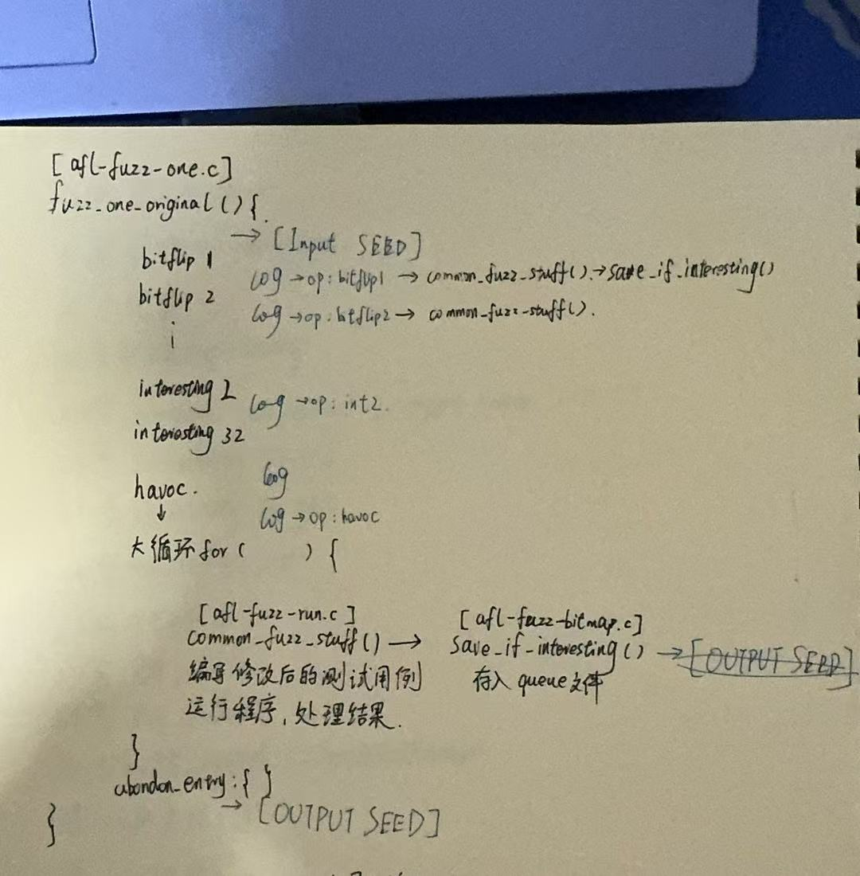

- Result
Our current data is stored in a linux system, so I will show a screenshot of the data I obtained.
These are all the mutation strategies that all seeds I have saved have gone through from its src mutation to its id.
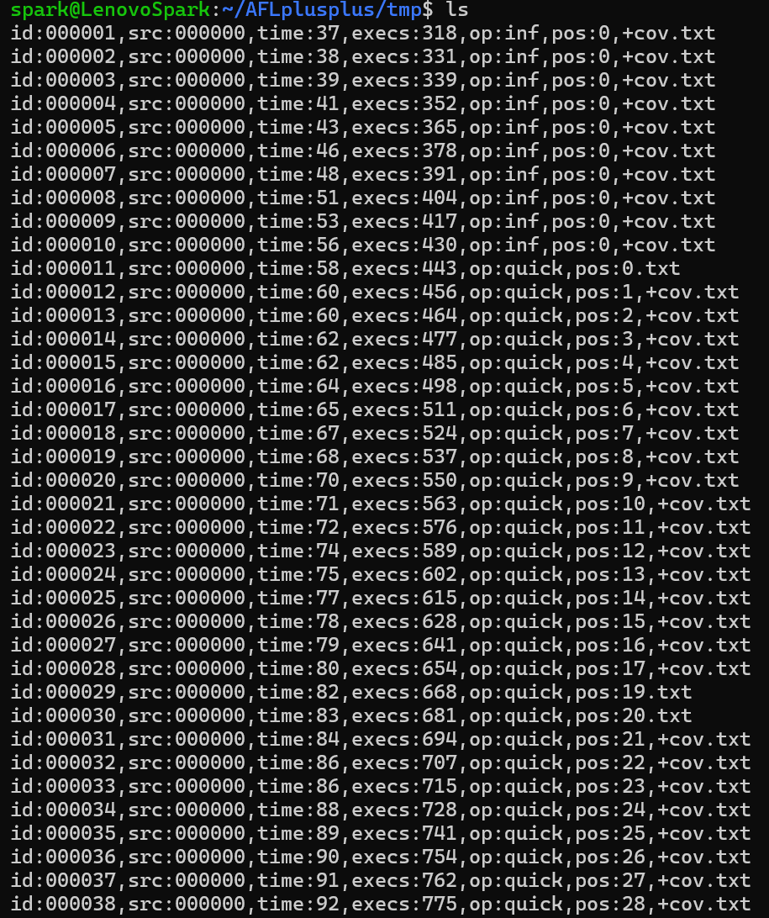
This is what all the seeds I saved look like before and after mutation.
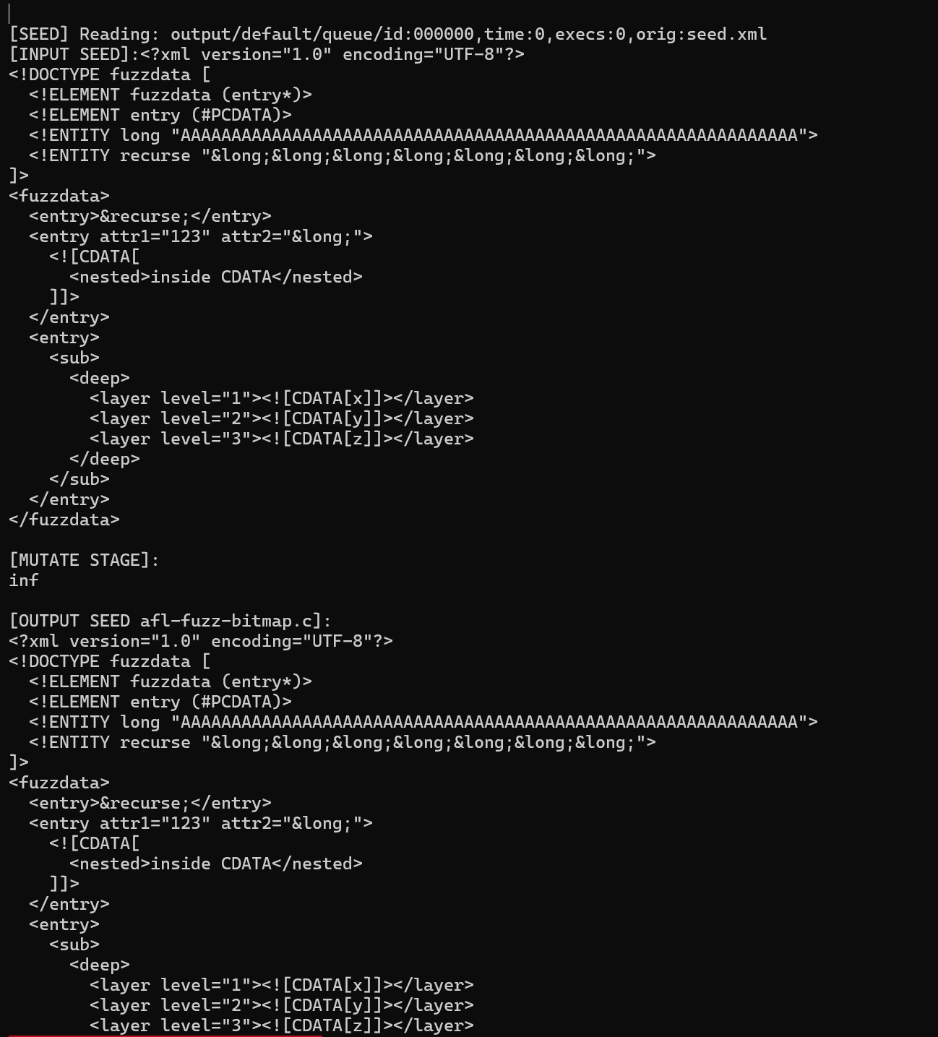

- Discussion
At present, the research project I am facing has reached the data analysis stage, which is to conduct a visual analysis of the data I obtained above.
We didn't find anything unexpected, we just learned the real working logic of afl++ and actually tried to change its source code.
- Conclusion
As this study is not yet completed, some major findings cannot be obtained at present. We will continue to study this project and submit a paper in September this year to complete our research.
- References
[1] Yan, Q., Huang, M., & Cao, H. (2022, July). A survey of human-machine collaboration in fuzzing. In 2022 7th IEEE International Conference on Data Science in Cyberspace (DSC) (pp. 375-382). IEEE.
[2] Grishin, M. (2022). Human-Controlled Fuzzing With AFL.
[3] Padhye, R., Lemieux, C., Sen, K., Simon, L., & Vijayakumar, H. (2019). Fuzzfactory: domain-specific fuzzing with waypoints. Proceedings of the ACM on Programming Languages, 3(OOPSLA), 1-29.
[4] Bundt, J., Fasano, A., Dolan-Gavitt, B., Robertson, W., & Leek, T. (2023, April). Homo in Machina: Improving Fuzz Testing Coverage via Compartment Analysis. In 2023 IEEE Conference on Software Testing, Verification and Validation (ICST) (pp. 117-128). IEEE.
[5] Vainio, J. (2014). The use of data visualization in fuzz test monitoring.
[6] Aschermann, C., Schumilo, S., Abbasi, A., & Holz, T. (2020, May). Ijon: Exploring deep state spaces via fuzzing. In 2020 IEEE Symposium on Security and Privacy (SP) (pp. 1597-1612). IEEE.
[7] Fioraldi, A., & Pileggi, L. P. (2021). Fuzzsplore: Visualizing feedback-driven fuzzing techniques. arXiv preprint arXiv:2102.02527.
[8] Hussain, A., & Alipour, M. A. (2021). Fmviz: Visualizing tests generated by AFL at the byte-level. arXiv preprint arXiv:2112.13207.
[9] Peng, Y., Li, X., Arya, S., & Wang, Y. (2023). Deft: A novel deep framework for fuzz testing performance evaluation in nextg vulnerability detection. IEEE Access, 11, 116046-116064.
[10] Fioraldi, A., D'Elia, D. C., & Balzarotti, D. (2021). The use of likely invariants as feedback for fuzzers. In 30th USENIX Security Symposium (USENIX Security 21) (pp. 2829-2846).
[11] Yan, Q., Cao, H., Lu, S., & Huang, M. (2023, July). InFuzz: An Interactive Tool for Enhancing Efficiency in Fuzzing through Visual Bottleneck Analysis (Registered Report). In Proceedings of the 2nd International Fuzzing Workshop (pp. 56-61).
[12] Shoshitaishvili, Y., Weissbacher, M., Dresel, L., Salls, C., Wang, R., Kruegel, C., & Vigna, G. (2017, October). Rise of the hacrs: Augmenting autonomous cyber reasoning systems with human assistance. In Proceedings of the 2017 ACM SIGSAC Conference on Computer and Communications Security (pp. 347-362).
[13] Lu, H. L., Zhuang, R. J., & Huang, S. K. (2023). Fuzz Testing Process Visualization. Journal of Information Science & Engineering, 39(5).
[14] Coppa, E., Izzillo, A., Lazzeretti, R., & Lenti, S. (2023, October). FuzzPlanner: Visually Assisting the Design of Firmware Fuzzing Campaigns. In 2023 IEEE Symposium on Visualization for Cyber Security (VizSec) (pp. 1-11). IEEE.
[15] Kadron, I. B., Noller, Y., Padhye, R., Bultan, T., Păsăreanu, C. S., & Sen, K. (2023). Fuzzing, symbolic execution, and expert guidance for better testing. IEEE Software, 41(1), 98-104.
[16] Nourry, O., Kashiwa, Y., Lin, B., Bavota, G., Lanza, M., & Kamei, Y. (2023). The human side of fuzzing: Challenges faced by developers during fuzzing activities. ACM transactions on software engineering and methodology, 33(1), 1-26.

